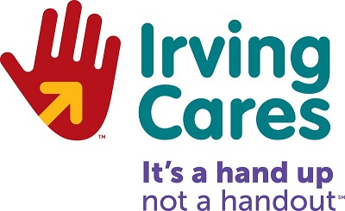

Holiday Food List

Canned Fruit

Canned Meats – Tuna, Chicken, Salmon, Spam

Canned Meals – Chili, Stew, Chef Boyardee

Peanut Butter

Any Soup

Box Meals – Skillet Dinners

Canned Vegetables – Peas, Mixed Veggies, Carrots, Leafy Greens

Sweet Potatoes or Yams

Hygiene Products – Soap, Shampoo, Conditioner, Toothbrushes, Toothpaste, Razors, Shaving Cream, Feminine Products

Powdered Laundry Detergent

Toilet Paper

