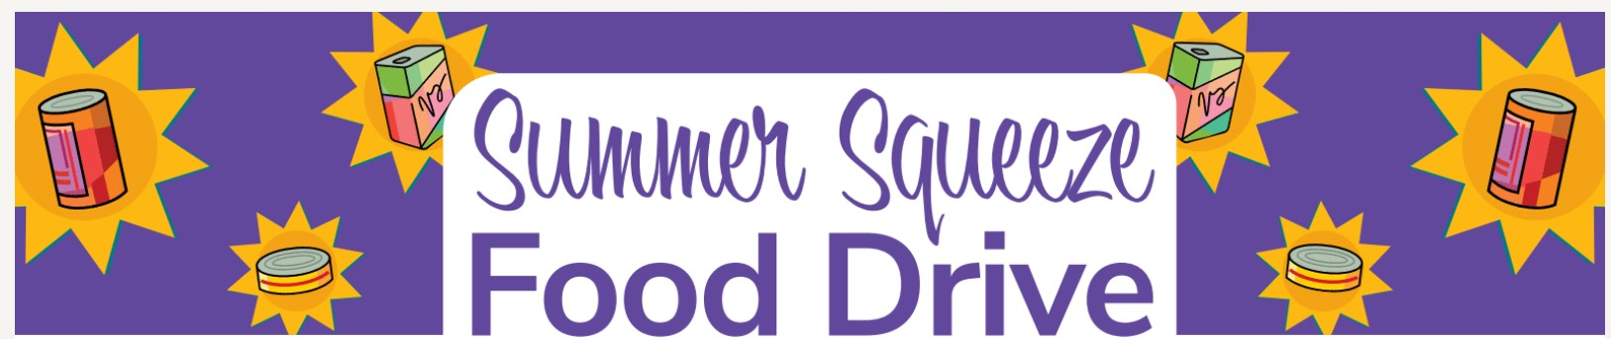

Food Pantry Needs

Peanut Butter & Jelly
Canned Fruit
Canned Meats – Tuna, Chicken, Salmon, Spam
Canned Meals – Chili, Stew, Chef Boyardee
ANY SOUP
Box Meals – Hamburger Helper, Tuna Helper, Macaroni & Cheese
Canned Vegetables – Green Beans, Green Peas, Mixed Veggies, Carrots, Corn
Toilet Tissue

Hygiene Products – Soap, Full Size Shampoo & Conditioner, Toothbrushes, Toothpaste, Razors, Shaving Cream, Feminine Products, Powder Laundry Detergent

Thank you for helping Irving Cares help our neighbors!

